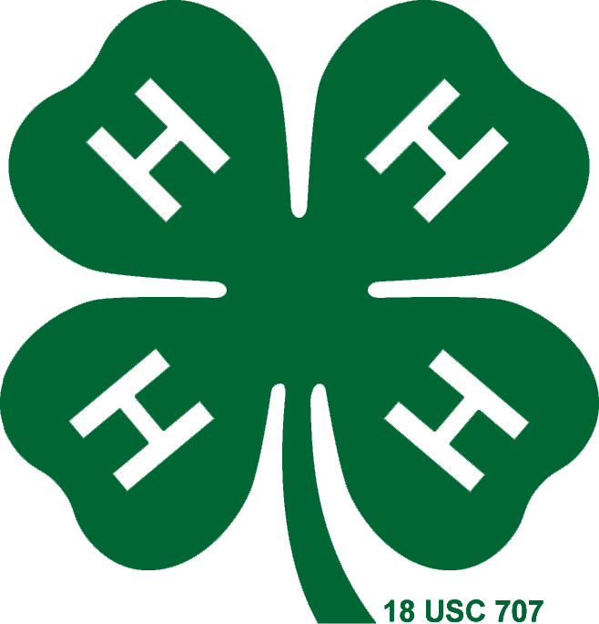

San Bruno/SSF General Meeting Agenda

October 12, 2016

**Call to Order:**

**Pledge and Flag Salute**

**President’s Notes**

**Treasurer’s Report**

**Secretary’s Report**

**Recreation Report**

**Farm Report**

**Community Leader Report**

**Old Business:**

Important Dates

* + County Council Meeting September 26th 7pm
  + Farm Clean Up September 17th 10-3
  + Open House September 18th 1pm

Enrollment/Farm Rules for the County

Sweatshirt 4-H

- Order Sheets

Bee Project Decision

December

**Program:**

Introduction to 4-H/Mini Presentations

Raffle

**New Business:**

Bringing Steer on the Farm

Halloween Party

-Sign Up Sheet

-Set up Date

Next Month's Community Service

-Presented by Alex

**Announcements**

-Birthdays